

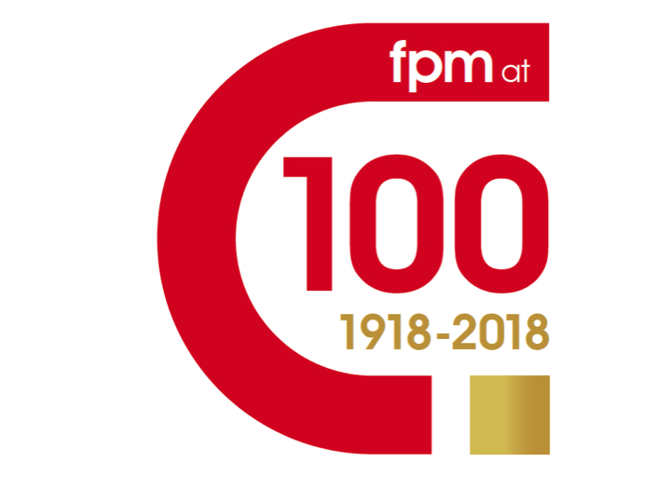
REGISTER NOW!
Clinical updates from international experts
Register online: thefpm.org.uk/fpm-at-100 Email leastman@bmj.com for further details
Registration: Standard £75 (£50 for trainees)
Hippocrates Prize entrants or PMJ or HPT authors £50 (£30 for trainees)

Eligible for 6 hours of CPD

8.30-9.45 Registration and poster display
9.45 Welcome Professor Dame Jane Dacre

9.50 The Fellowship of Postgraduate Medicine Prof. Donald Singer, FPM; Professor Bernard Cheung, University of Hong Kong; Assoc. Prof. Ken Redekop, Erasmus University, The Netherlands
10.10 Prescribing challenges in modern practice Prof. Jamie Coleman, Birmingham University

10.40 Dealing with difficult hypertension Prof. Una Martin, Birmingham University

11.10 Coffee and posters

11.40 What to do about non-alcoholic fatty liver disease? Prof. Christopher Byrne, University of Southampton

12.10 Treating asthma and chronic obstructive pulmonary disease Prof. Peter Barnes, NHLI, Imperial College of Medicine, London
12.40 Lunch and poster prize judging
13.30 Readings from the Hippocrates Prize for Poetry and Medicine Prof. Michael Hulse, University of Warwick, Wendy French, London, Jane Draycott, Henley-on-Thames
14.00 What to do about malaria? Prof. Sanjeev Krishna, St George’s, University of London

14.30 Ageing and multi-morbidity Prof. Tom Kirkwood, University of Newcastle

15.00 Personalised medicine in clinical practice Prof. Sir Munir Pirmohamed, Liverpool University

15.30 Tea and posters

16.00 Functional neurological symptoms Dr Tim Nicholson, Institute of Psychiatry, Psychology & Neuroscience, King’s Medical School
16.30 Reducing severity of stroke Prof. Anthony Rudd, Clinical Director for Stroke, NHS England
17.00-18.00 Posters, Poster Awards and Reception

